WICKFORD YACHT CLUB 2026 CRUISE
August 1st to August 7th, 2026

Commodore- Suzanne Thoms M: 401.932.3306
Vice Commodore- Jeri Levesque M: 314.703.7473
Rear Commodore- Mike Tammaro M: 401.480.2600
Fleet Captain- Siobhan Obara M: 508.246.8913

Welcome all to the WYC summer cruise. We look forward to a great time with great friends.
This guide provides an overview of our plans.
Captains, please remember that safety of your crew and your boat are your first responsibility. We’ll only keep to this plan if weather, boat, and personal conditions allow. Changing plans to stay conservatively safe is the responsibility of each Captain and every crew member.
The Fleet Captain’s Daily summary and discussion of the day’s activities on Ch 78 will be at 8am and 3pm. The 8am call topic will be primarily weather and logistics, the 3pm call will be primarily social.
Stay safe, have fun, see you out there!
CRUISE OVERVIEW:
M
Sat - Sun 8/1 - 8/2: Cuttyhunk Port Captain: Randy Wietman M: 401.439.6389
Sun - Mon 8/2 - 8/3: Onset Port Captain: Carl Bowen M: 401.742.1959
Mon - Wed 8/3 - 8/5: Provincetown, MA Port Captains: JT Thoms & Jeri Levesque M: 401.932.3305
Wed - Fri 8/5 – 8/6: Sippican Harbor, Marion Ma Port Captain: Jen LeComte (honorary)

2026 Plan |  | 1-Aug | 2-Aug | 3-Aug | 4-Aug | 5-Aug | 6-Aug | 7-Aug
 | Day
 |  | Sat | Sun | Mon | Tues | Wed | Thurs | Fri
 | Port
 |  | Wickford | Cuttyhunk | Onset | Ptown | Ptown | Marion | Open to Personal Plans
 |  | Cuttyhunk | Onset | Ptown |  | Marion
 | Distance | 25.27 NM | 22.65 NM | 27.93 NM |  | 33.25 NM
Events: |  | Welcome Party! | Informal Dinner |  | Commodore’s Cocktail Celebration  Provincetown Marina |  | Drinks and Apps at the BYC Bar then Informal Dinner

High Level Details on Cuttyhunk:

This weekend (8/1 and 8/2) is particularly busy. Even more so than in other years. We have our social event reserved on the grounds of the Cuttyhunk Historical Society Museum from 4:00 to 6:00 on 8/1. Please know that there are several other activities on the island that particular weekend, so there will be an additional demand for moorings, inside and outside the harbor, so work your solution now. Rafting may be your best option.

Events on Cuttyhunk during our stay:
* WYC Social Event - Cuttyhunk Historical (Aug 1st/4-6pm)
* Cuttyhunk 5K race the morning of arrival (Sat, Aug 1st)
* Community Potluck Dinner at Library (Sat, Aug 1st/6-8pm)
* CHS Annual Meeting (Sat Aug 1st)
* Also 5 other yacht clubs there that weekend. East Greenwich YC, WYC, New England Tug Association, Cruising Club New England and BYC (Sat, Aug 1st)
*Water and pump-out are available.
*Trash and recycling are taken near the restrooms by the dinghy dock. Restrooms are open 24/7, but there are no showers.
*Gas and water are available at the fuel dock.
*The small grocery store up the hill from the dinghy dock is now closed, but there is a small store on the fuel dock that has groceries and some boating supplies. Check it out if you have forgotten something - they may have it!
*Ice is available at the fuel dock or at the fishing dock near the marina
*There is a lobster shack, an ice cream stand and a BBQ and burger food cart near the dinghy dock. Coffee, pastries and breakfast sandwiches are available on the fishing dock near the marina. Cuttyhunk Fishing Club has full breakfast. Soprano's Pizza is a short walk from the dinghy dock, just past the 4 corners.

Please note: the biggest change for moorings is that the inner harbor will no longer be first come / first serve. All reservations though Dockwa for slips and moorings. The two other mooring fields in the outer harbor of Cuttyhunk Island to the North and South of Red Bell #6 are run by companies separate from Cuttyhunk Marina. The mooring field to the North is by reservation only and listed as "Cuttyhunk Outer Moorings" (508-802-8633) in the Dockwa System. The mooring field to the South is first come, first serve and run by Frog Pond Marine (508-992-7530). Please contact these companies directly with any questions or issues regarding their mooring fields. If you're reserved for the inner harbor, hail on Ch 9 just before entering the inner harbor.

Cuttyhunk Sat Aug 1 (arrival after 1:00)
Cuttyhunk Sun Aug 2 (Departure before 11:00)

_____________________
Cocktail Party at Cuttyhunk
On August 1st, 1600 (4 PM) the WYC Summer Cruise kicks off with a cocktail party at the Cuttyhunk Historical Society. The format is BYOB and BYOA to share. On the lawn of the Cuttyhunk Historical Society. Please bring your favorite appetizer or hors d'oeuvres to share with other club members. This is located approximately 300 yards (aka, a short walk) from the dinghy docks.

Cuttyhunk Historical Society
23 Tower Hill Road, Cuttyhunk, MA 02852

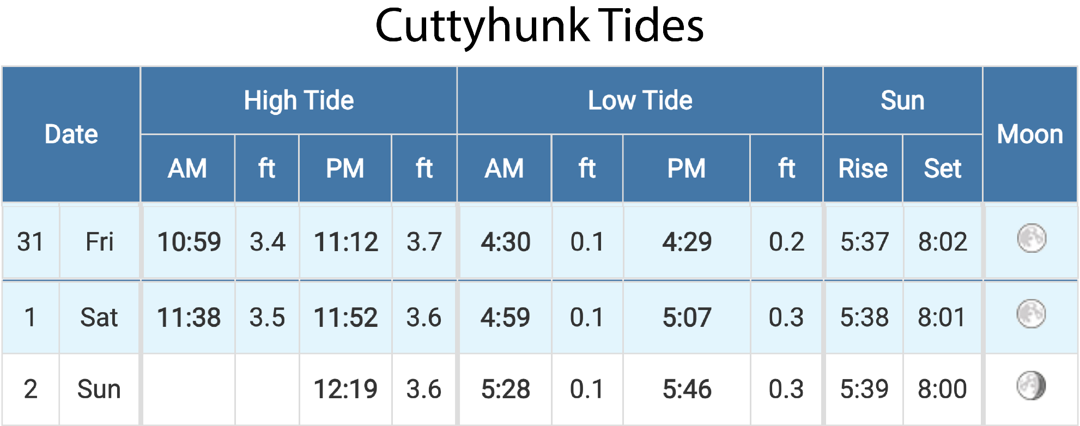
High Level Details on Onset:
Port of Call August 3 (1 night)

About Town of Wareham Harbormaster - Onset Harbor Transient Moorings
Welcome to Onset Harbor and the Victorian seaside community that overlooks it. Vessel fuel, Yacht Club, full-service marinas, Dining, groceries, laundry and the post office are all within walking distance of the Onset Village Town Pier and within Onset Harbor.
The Wareham Harbormaster is responsible for the Town’s transient moorings that can welcome vessels up to 50’ and 7’ draft. Complimentary launch service is available to vessels staying on the towns transient moorings when the launch is in operation. There is also a public pier and dock available for vessels to pull in as well as a dinghy dock.
The fixed pier bulkhead is available to vessels from 50’ to 110’ and can accommodate vessels with up to 9’ draft. Vessels are not to be left unattended for extended periods of time.

Onset is an attractive destination with a Victorian resort feel with biking, hiking and beach going that offers something for most everyone. Part of the allure of Onset Village is that it feels like a perpetual vacation town – antiques, shops and homes with picket fences. The Onset Bandshell hosts a summer concern series, free family-friendly movies and other events. For beach recommendations – try Onset Beach or Shell Point. Massachusetts Maritime Academy sits on Taylor’s Point at the mouth of the canal.

Restaurants and Provisions
Guests at the Stonebridge Marina are lucky to be able to dine dockside at Stonebridge Bar & Grill (508-291-2229). Menu features surf-and-turf; seafood entrees and grilled pizzas. For waterfront dining at shallow but scenic Buttermilk Bay, Captain Al’s Restaurant and Tiki Bar (508-759-0811) is adjacent to the Continental Marina – is a local favorite. Uphill from the town pier, the Quahog Republic Waterfront Eatery (508-295-9300) has lunch, dinner and cocktails. Up the street, Pier View Restaurant (508-295-5968) whips up hearty breakfasts while Marc Anthony’s Pizzeria (508-295-5956) dishes out tasty pies.
If you are in need of a resupply, visit the Stonebridge Marina (508-295-8003) and their business partner Atlantic Boats (508-295-8005) Another option is Safe Harbor Onset Bay (508-295-0338).

Tides:

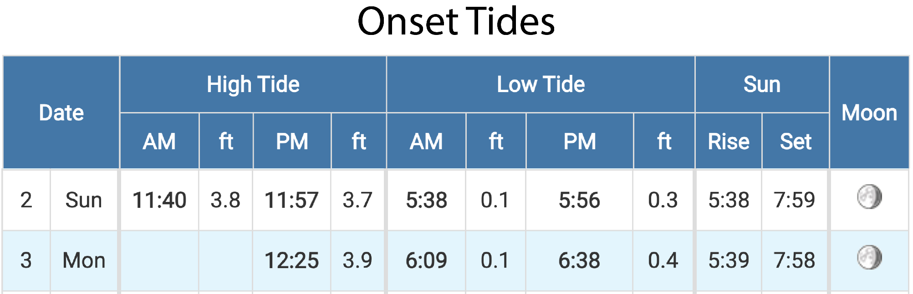

Navigation: Onset Harbor
There is only one approach into Onset, and it’s from Hog Island Channel. The markers around this entrance can be confusing. Hog Island Channel’s Q 35 ft 5M “21” is a good landmark. However, it is not the entrance buoy. You must enter south of this marker at G C “1” off Hog Neck. Do not cut into Onset Bay Channel north of Q G 35ft 5M “21” where depth fluctuates dramatically.
From G C “1” off Hog Neck, the well-marked Onset Bay Channel leads you all the way into town. Keep looking fore and aft to make sure that strong currents from the Cape Cod Canal have not pushed you outside the channel. The is a minimum controlling depth of 12 feet up to the town pier.

Booking Info
Launch Service is in operation.

Phinneys Harbor (part of Bourne) is a great spot to anchor while waiting for a favorable tide in the canal. Overnight anchoring requires permission from the harbormaster (VHF 9 or 508-759-0600, x1504)
Shoreside and Emergency Services
Harbormasters:
Onset 508-295-8160 or VHF 9; Phinneys (Bourne) 508-759-0600 x1504 or VHF 9
Tow Service:
Sea Tow 800-4SEATOW or VHF 16; TowBoatU.S. 800-391-4869 or VHF 16
Currents for Cape Cod Canal
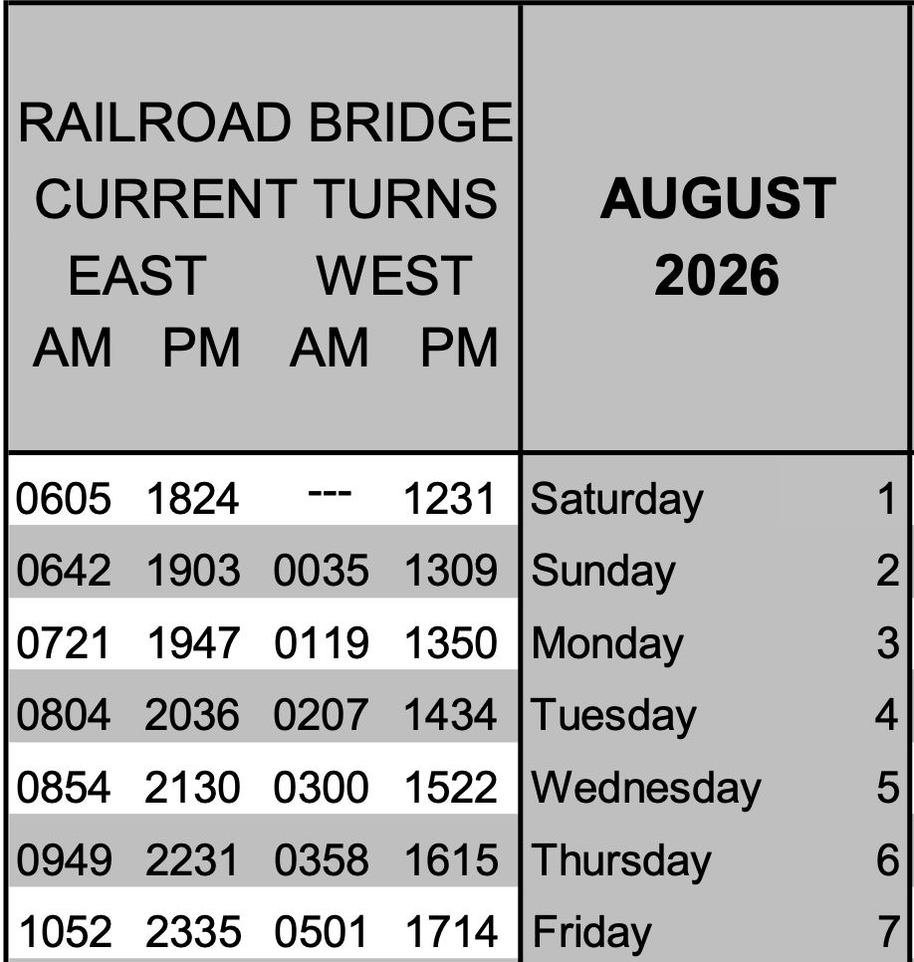

Details on Provincetown:
Port of Call August 4 -6 (two nights): Provincetown, MA
Situated at the distinctive tip of Cape Cod, surrounded by miles of beaches and dunes, Provincetown Marina is your gateway to this something-for-everyone kind of town. It boasts an enviable location that’s home to important historical landmarks and the oldest continuous art community in the United States. Experience a place that has long been connected to a sense of freedom.

Approach & Navigation
- Enter via the well-marked channel from Cape Cod Bay (NOAA Chart 13249)
- Watch for shoaling outside the channel and strong tidal currents.
- Be alert about frequent ferry and commercial traffic.
- Fog is common - radar and sound signals are recommended.
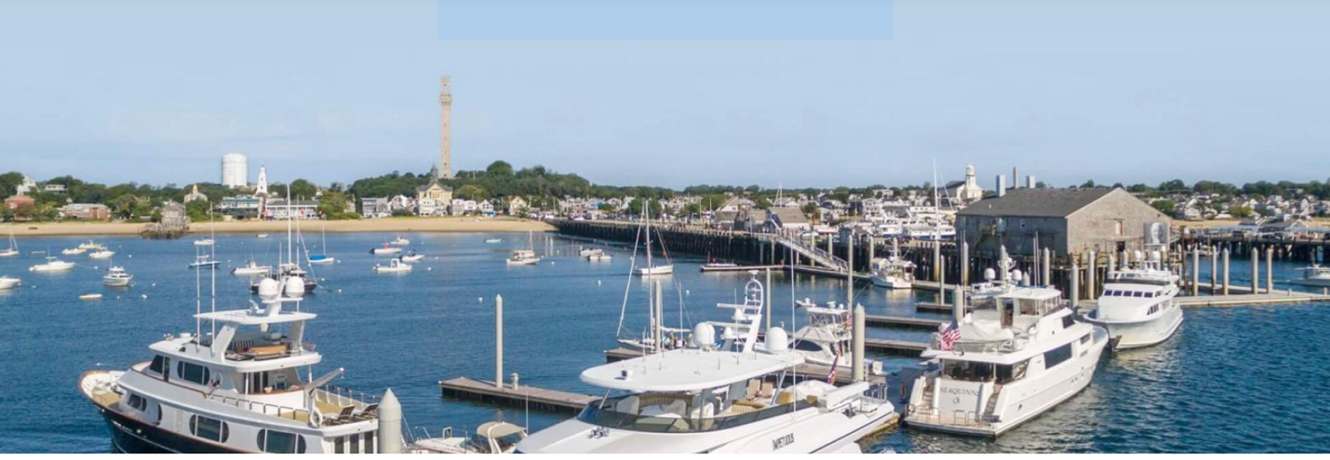

Harbormaster: VHF Channel 12 (hailing 7 working) Phone: (508) 487-7030
Moorings Dockage & Anchorage
Harbor Conditions
- Generally, well protected; exposure in strong N/NW winds.
- Tidal range ~8–10 feet—plan dock and launch timing.
- Busy harbor—maintain no-wake awareness and watch traffic.
📡 Key VHF & Contact Information
- Provincetown Marina: VHF 9 | (508) 487-0571 (PYC)
- Flyer’s Boat Yard / Launch: VHF 11 | (508) 487-0898 (PYC)
- Long Point Marina: VHF 14 | (774) 593-5120 (PYC)

Provincetown Marina 42º2’54N. 70º10’57W 9 Ryder Street Ext. Provincetown, Mass.
VHF: Channel 9 Tel: 508-487-0751 Info@ptownmarina
- Extensive town mooring field with launch service available. Reservations STRONGLY recommended.
- Anchorage permitted in designated areas (good holding in sand/mud)
- Dinghy dock is located at MacMillan Pier
Reservations OPEN NOW on Dockwa
Mooring Rates: 25’ minimum - $3.00/ft. per night
Dockage Rates: 30-35’ - $6.75/ft. per night 35.1’-60’ - $7.75/ft. per night
- Check-in after 1pm
- Check out no later than 11am
- Requests for specific slips and moorings are encouraged but CANNOT be guaranteed
- Pump out facilities are free and mandatory for extended stays (beyond seven days) or at your holding tank’s capacity, call dock office for pump out information
- All major credit cards are accepted
Best Things to Do in Provincetown (Aug 3–4)
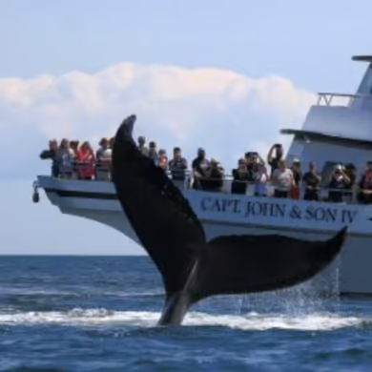

🏖️ Race Point Beach – Cape Cod National Seashore
Why Visit
- A gorgeous beach at the tip of Cape Cod with big Atlantic views, soft sand, and dunes.
- It’s great for wildlife viewing to spot whales, seals, migratory birds. Excellent bike trails, swimming, walking, or viewing sunset.
- Visit historic Race Point Light house.
- Tip: Go late afternoon for sunset—one of the best on the East Coast.

🏛️ Climb the Pilgrim Monument

The Pilgrim Monument is the tallest all-granite structure in the U.S. at 252 feet and commemorates the Pilgrims’ 1620 landing in Provincetown Harbor.
Why visit:
• Climb to the top for spectacular harbor views
• Includes the Provincetown Museum about the town’s maritime and cultural history.

🎨 Art Galleries & Museum
Why Wander?
- Provincetown is America’s oldest continuous art colony.
- Visit the Provincetown Art Association and Museum, founded in 1914 and home to works by Cape Cod artists across multiple movements.

🚲 Bike the Province Lands
Why Peddle?
- This is one of the most unique landscapes in New England.
- Rent a bike and ride the Province Lands bike trails through sand dunes and pine forest to the ocean.
- Highlights:
• Herring Cove
• Race Point
• Wild dunes scenery

🐋 Provincetown Whale Watching 4 Hour Cruise MacMillan Pier 12:30 PM Departure
One of the signature Provincetown experiences. Boats leave from MacMillan Pier and head to Stellwagen Bank, a major feeding ground for humpback and fin whales. Trips are usually 3–4 hours, and many operators guarantee sightings. Cost: $78 per person
Why it’s worth it:
- Humpback whales often breach in summer
- Naturalists explain marine life
- Beautiful views of Cape Cod from the water
🌈 Nightlife & Shows

Provincetown is famous for its entertainment scene.

Popular options:
• Drag shows
• Cabaret and comedy
• Live music

A classic venue is The Crown & Anchor, which hosts energetic drag and cabaret shows.

🚶 Walk Commercial Street

The heart of town:
• Art galleries
• Seafood restaurants
• Independent shops – Cheesy sweatshirts
• People-watching

It’s one of the most fun streets in New England.

Suggested 2-Day Itinerary

Day 1 Day 2

Noon (12:30 Departure) Morning
• Whale Watch Cruise • Bike the Province Lands trail

Afternoon Afternoon
• Lunch on Commercial Street • Art Association & Galleries
• Pilgrim Monument + museum • Beach at Herring Cove

Evening Evening
• Race Point sunset • Sunset harbor cruise
• Drag show or cabaret • Dinner on the waterfront OR

Recommended for Dinner on August 4th
Arts Dune Tour

https://artsdunetours.com/

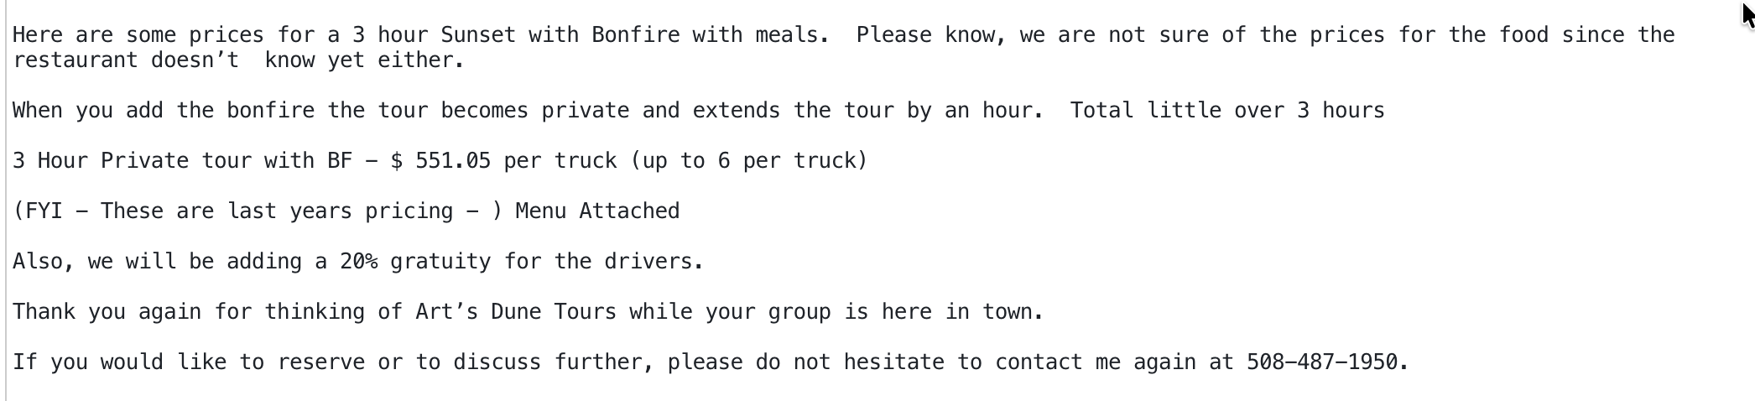
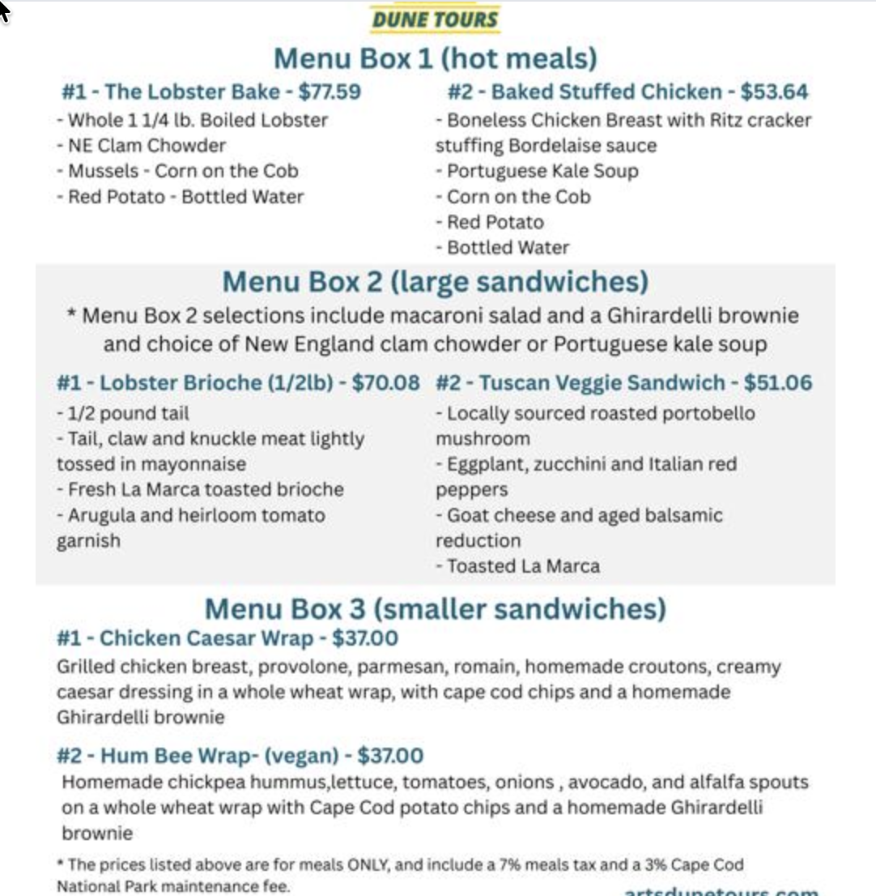
⸻

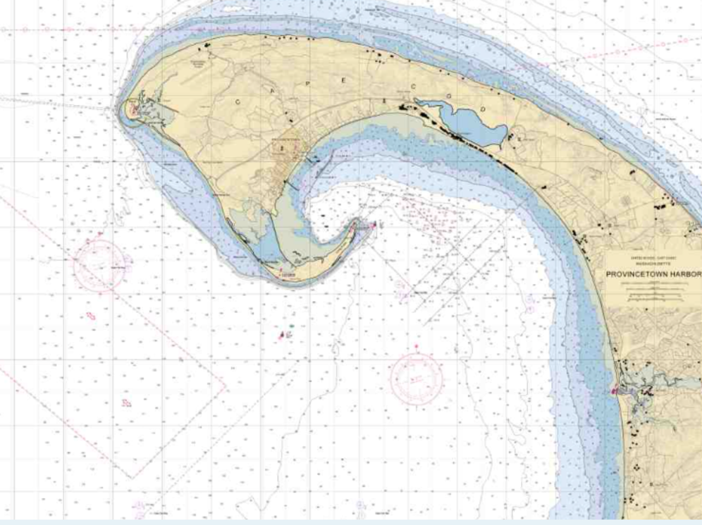

Provincetown Tides
Date |  | High Tide |  |  |  | Low Tide |  |  |  | Sun |  | Moon
 |  | AM | ft | PM | ft | AM | ft | PM | ft | Rise | Set | Moon
3 | Mon | 3:01 | 9.9 | 3:26 | 9.9 | 9:09 | 0 | 9:34 | 0.2 | 5:36 | 7:57
4 | Tue | 3:46 | 9.7 | 4:09 | 10 | 9:52 | 0.1 | 10:23 | 0.1 | 5:37 | 7:56
5 | Wed | 4:35 | 9.5 | 4:56 | 10 | 10:38 | 0.3 | 11:16 | 0.1 | 5:38 | 7:55
Commodore’s Cocktail Party
August 4th. Provincetown Marina’s Barn. 6:00 PM

Commodore Suzanne Thoms cordially invites you to the annual cruise Commodore’s Cocktail Party on August 4th at the Provincetown Marina. Please join us for a relaxing early evening of cocktails, conversation, and celebration by the water. The festivities will begin at 6:00 PM and are open to all WYC land and sea cruisers. and their guests.
Dress is casual. Kindly RSVP by July 15th to ensure your spot at this special event. We look forward to seeing you there!
Cost: $65 per person. This includes the facility rental fee, a variety of delicious catered appetizers from Far Land, “Stone Soup” bar*, use of the “Barn” at the marina from 3 pm to 10 pm. Cruisers are invited to relax at the Barn which includes seating, and grills during our rental period. Bring your beach chair to sit outside. Launches are available from the Marina to your boats until 11 pm.

*To reduce the cost of the event, the Port Captains invite cruisers to donate beverages in advance to create a Stone Soup bar of alcohol and non-alcohol beverages. Wine, beer, hard spirits, seltzer, soda, and mixers – just a little from each cruiser will go a long way! We will set up the bar inside the “Fish Shed” facility at the marina. Please drop your contribution off at the club between July 15th and July 25th in a box marked “Stone Soup for Cruising the Canal”.

Details on Beverly Yacht Club – Sippican Harbor – Marion:
Port of Call: BYC, Sippican Harbor - Marion (Two Nights) : August 5 – 6
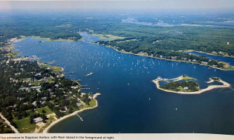
Marion’s Sippican harbor is one of the best all-round harbors on the coast. To the east of the entrance is Bird Island Lighthouse. To the west is Blake point, marked as Converse Point on charts. This western shore should be given a wide berth as there are many outlying rocks. Once in the harbor proper, you will see the Beverly Yacht Club to the west.
Captains will dock/moor with either Burr Bros or with BYC. Those with Burr Bros will have had confirmation through DOCKWA. All others will be with BYC. Anchorage is available in a few spots in the harbor as well. There may be room to the north of Little Island in 9 feet of water or try south of Ram Island in deeper water but mind the rocks.
If you made a reservation with DOCKWA at Burr Bros.: Hail Burr Bros. on CH 68 (508)748-0541. To the extent possible, Katie the dockmaster will be on a working boat and guide to mooring. They are fully booked and some rafting, two-to-a-mooring, may be required.
If you made a reservation with the Beverly Yacht Club: Hail BYC on CH 68 (508)748-0540.To the extent possible, Annette the dockmaster will be on a boat to guide you to the mooring. She may provide directions to the mooring in the day or two before arrival, to ease congestion. Some rafting may be required.
Organized in 1871, The Beverly Yacht Club is one of the oldest in the country. It is said that it was founded at a supper party held by Edward and Walter Burgess in their Boston home. This is the family (Edward and Starling) who designed so many successful defenders to the America’s cup. (And for more trivia – Starling’s daughter was Tasha Tudor).
Marion is a good supply port. Full-service yards, Barden’s and Burr Brothers both have small ship’s chandleries and fuel docks. The harbor master’s office is located just north of Barden’s.
Baked goods, liquor, gifts and other galley provisions may be purchased at the General Store located on Front St. If you feel like stretching your legs, consider a less than 2-mile hike to Fieldstone Market. A passion for the good earth held by the market’s owner, Arnie Johnson, can be savored in the local produce grown on his farm. The store also offers specially prepared foods. The walk will make everything taste all that much better. Be sure to bring a back-back. http://www.fieldstonefarmmarket.com/
The Sippican Historical Society maintains the Mary Celeste Museum in the center of Marion. Captained by Benjamin Brigs, the doomed half -brig’s crew completely disappeared off of the Azores in 1872, remaining one of the world’s greatest sea mysteries.
http://www.sippicanhistoricalsociety.org/ There is also the Marion Art Center https://www.marionartcenter.org/ and the Marion Natural History Museum located within the Elizabeth Taber Library https://marionmuseum.org/.

Tides:
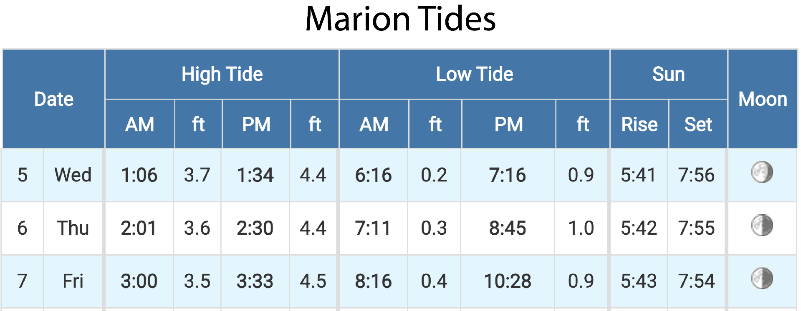
Charts:
Use Maptech ChartKit Region 2, Pages 33 and 35; Maptech ChartKit Region 3, pages 75 and 83A; NOAA charts 13229 (1:40, 000) 13230 (1:40, 000) and 13236 (1:20, 000)

Marion is a modest waterfront harbor. It is slightly open to the southwest winds that frequently blow across the bay in the summer but north of Ram Island is well protected.
The Marion waterfront in Sippican Harbor is 8 miles from Fiddlers Cove Marina in Megansett Harbor, 10 miles from the Cape Cod Canal entrance at Taylor Point, 12 miles from Woods Hole Passage and 18 miles from the hurricane barrier at New Bedford Habor.
All approaches to Sippican Harbor are marked by R”2” F1 R 4s at Centerboard Shoal, about 1 mile south and west of Butler Point, and by G “3” F1 G 2.5s off Converse Point. To the west of Converse Point, you will see Aucoot Cove and Hiller Cove. These spots may look nice as you pass them, but they are exposed to the southeast, with shoals and rocks as far as 400 yards offshore at low water. This area on a good, breezy day is prime windsurfing territory, so keep that in mind as you cruise through.
From the south and west, approach Sippican Harbor by heading for a point well to the southeast of G “3” F1 G 2.5s about 500 yards east of Converse Point. This buoy marks Mendells Rocks and the southeastern end of Seal Rocks. Give it a WIDE BERTH. Deeper-draft vessels must be aware of the Bow Bells, shoals about 1.2 miles south of Converse Point, which are covered by 11 feet.
From the north and east, you will have to round south of Bird Island Reef (marked by G “3” BELL) and Bird Island south of Butler Point on Sippican Neck. The 36 foot tower on the island, a tern sanctuary, is a good marker. If you are navigating at night, use R “2”F1 R 4s at Centerboard Shoal as your entrance marker.
DO NOT cut between Butler Point and Bird Island. There are several shoal spots and submerged rocks between these points.
Once at the habor’s entrance, follow the marked channel west of Planting Island. If you are coming in at night, be aware that there are no range lights. At G C “7” the channel narrows ad doglegs around the shoals off Ram Island and Little Island. Once you are north of Little Island (on the west side) the moored boats help define the channel.
CAUTION: the well marked channel into town is narrow and there are foul spots on both sides. Local boaters recommend going from green to green, keeping the cans close to port.

Shoreside and Emergency Services
Coast Guard Rescue Coordination Center: 911 or VHF 16
Airport:
New Bedford Municipal 508-991-6160
Harbormaster:
508-748-3535 or VHF 9
Tow Service:
Sea Tow 800-4SEATOW or VHF 16
TowBoatU.S. 800-391-4869 or VHF 16

